ASR 6002 IBMMSPL (STC) import shipment report   
Date: 2016.03.04

Report format changes - the report heading change and impact the data position.

Original New changes

“IBM/Lenovo PO Number” “IBM PO Number”

“IBM/Lenovo Part Numb” “IBM Part Number”

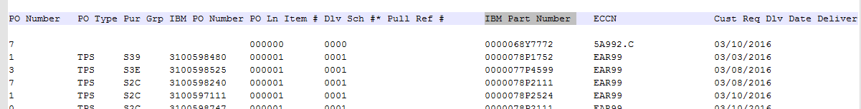

WMS Changes:

EOD – autoreport.

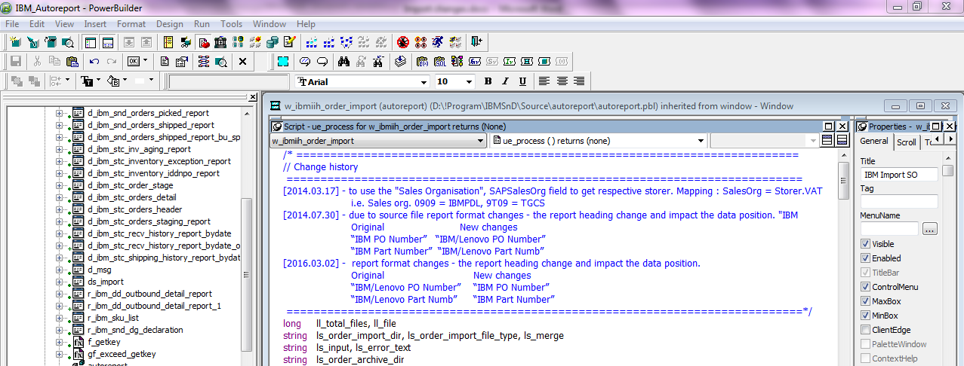

Fixed length:

inv_import.of_Setdelimeter('H','1-19,20-55,56-91,92-112,113-120,121-128,129-142,143-155,156-166,167-183,184-202,203-223,224-241,242-260,261-291,292-307,308-322,323-343,344-364,365-385,386-406,407-417,418-468,469-519,520-570,571-621,622-672,673-723,724-774,775-815')